Block 2 Challenge – Turbo Encabulator

# Purpose

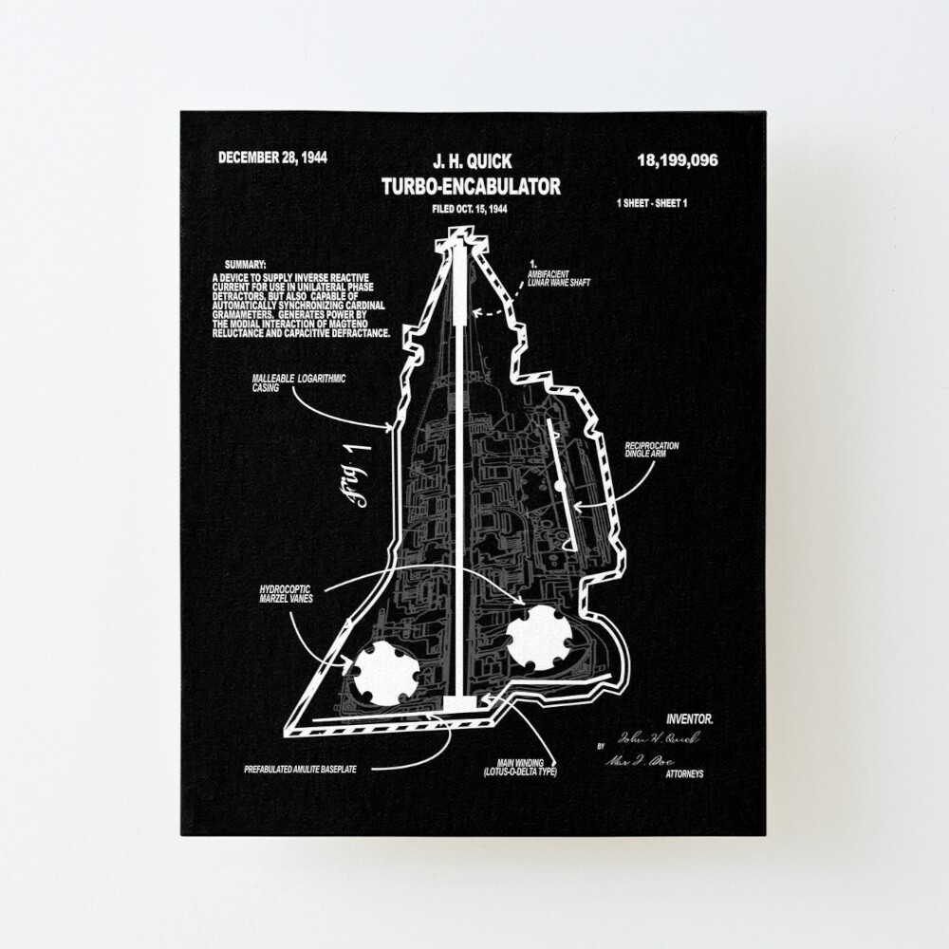

Figure 1

This webpage will primarily entertain visitors by exploring an old engineering joke called the “Turbo Encabulator” (Figure 1). Based on a joke created by J. H. Quick in the 1944 *Student’s Quarterly Journal*, this webpage will bring the story and principles of the Turbo Encabulator to life. Users will be able to view and “purchase” different products and clothing based on the Turbo Encabulator, using the website as if buying an actual Encabulator for themselves.

# Audience

The target audience are those who know of the Turbo Encabulator, but resources will be provided to illustrate the Encabulator to first-time viewers. Videos describing the Encabulator will be available to view, and “purchasable” products will be listed on each page. A downloadable “Maintenance Guide” will also be supplied, so users can read a brief description of how the Encabulator functions.

# Data Sources

The main data source for this webpage will be:

* Device localStorage

# Initial Module List

At most, two JavaScript files will be used to handle different methods:

1. pullItemData.js – This file will handle the primary back-end website functionality, such as displaying item information in each individual product card (Figure 3). As the user clicks on a card to expand product details, this file will handle displaying those details.
2. main.js – This file will handle the secondary back-end functionality of the website, such as product “purchases”, total cost counting, and event-listeners (i.e., checking a box).

# Wireframes

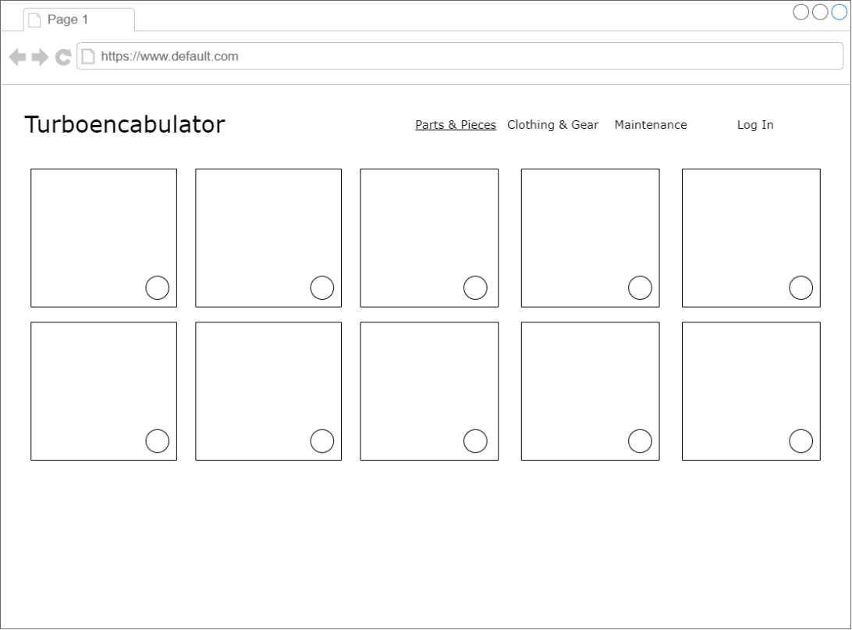

Figure 3

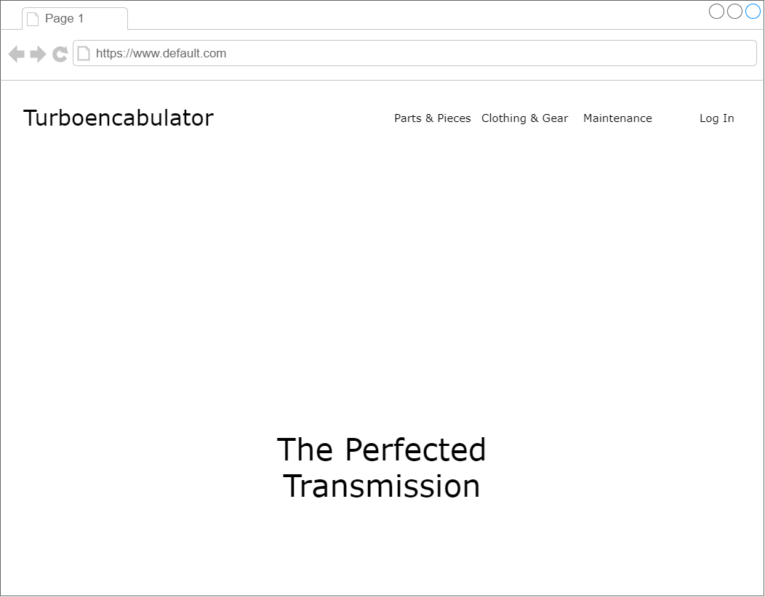

Figure 2

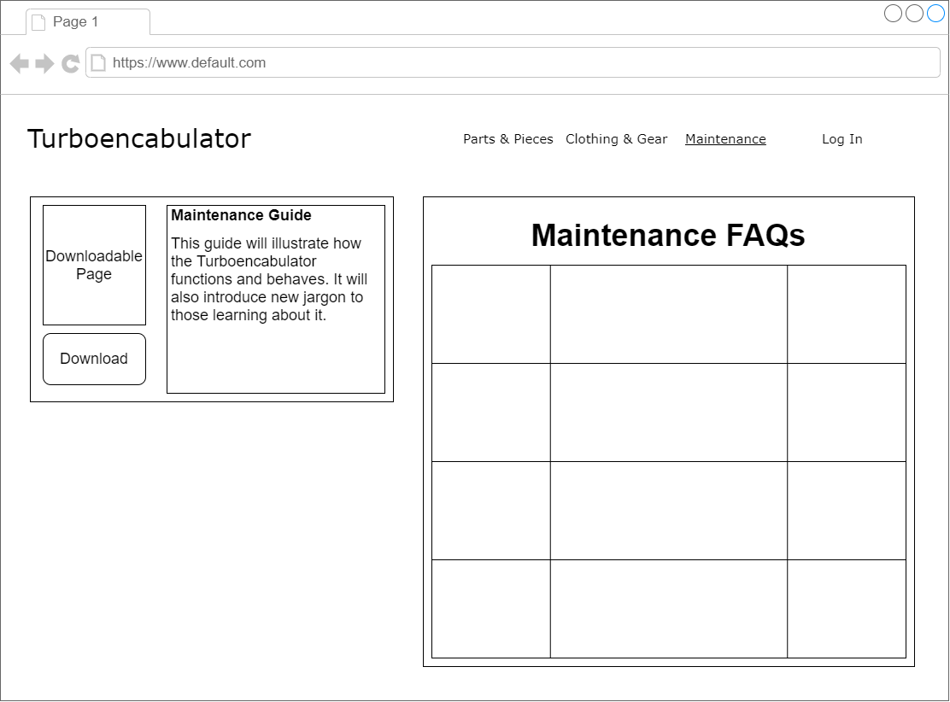

Figure 4

# Color/Typography/Element Styling

## *Colors*

|  |  |  |  |  |
| --- | --- | --- | --- | --- |
| #ffffff | #00171f | #003459 | #007ea7 | #00a8e8 |

## *Typography*

* font-family: 'Bebas Neue', cursive;
* font-family: ‘Ubuntu’, sans-serif;

## *Element Styling*

* Auto-template-columns, entirely using a responsive grid layout to perform best on all screen sizes.

# Schedule

|  |  |
| --- | --- |
| Week # | Milestone Marker |
| Week 10 | Begin designing the main page layout:   * Construct grid layout * Add headers, icons, and tab text * Link pages together * Add some pictures |
| Week 11 | Finish front-end layout and begin JS files:   * Finish adding pictures * Begin writing array lists for product descriptions * Add event listeners for checkboxes |
| Week 12 | Continue JS file writing:   * Debug event listeners * Construct JSON and localStorage events * Test customer order purchase total |
| Week 13 | Finalize project:   * Continue debugging event listeners and JSON localStorage * Perform webpage functionality test making “purchases” |
| Week 14 | Turn in report:   * Report on final project |